Dja Regional REDD+ Project

Program Developers:

Conservation Action Research Network (CARN), a US based 501.c.3

Contact: Thomas B. Smith, PhD, President
CARN
3463 Tuna Canyon Rd
Topanga, CA 90290 USA
(310) 913-5791
tbsmith@ucla.edu

Center for Tropical Research – Cameroon (CTR-CAM), a Cameroon based NGO

Contact: Kevin Njabo, PhD
P.O. Box 3055 Messa
Yaoundé, Cameroon
(310) 405-3396
+237 75 39 10 99
kynjabo@ucla.edu

Affiliated Researchers and Collaborators:

Edward Mitchard, PhD - University of Edinburgh
Hilary Godwin, PhD - UCLA/CARN
Sassan Saatchi, PhD - Jet Propulsion Laboratory/ UCLA
Brian Cole, PhD - UCLA
Zac Tchoundjeu, PhD - World Agroforestry Center
Rachid Hanna, PhD – International Institute of Tropical Agriculture

Executive Summary

The Dja Regional REDD+ (Reduced Emissions from Deforestation and Forest Degradation) Project aims to reduce deforestation and degradation in and around the Dja Biosphere Reserve (DBR), an UNESCO World Heritage Site with extraordinary biodiversity and ecological value. The project covers 1,220,688 hectares (ha), including the Dja Biosphere Reserve and a surrounding buffer zone (Figure 1). The Government of Cameroon has identified this project as a showcase REDD+ project for the country (see attached letter). Under conservative assumptions, it is estimated that the project will result in a reduction of 68 million tons of carbon dioxide equivalent (tCO2e) over the first 50 years. The project will also reduce bushmeat hunting, protect and enhance biodiversity, increase forest cover in the buffer zone, and provide programs to improve health, education, incomes and income-stability of local communities while creating green jobs. The project will be developed in cooperation with the Government of Cameroon, the Conservation Action Research Network (CARN, a non-profit research institute), the Center for Tropical Research - Cameroon, a local Cameroon NGO (CTR-Cameroon) comprised of research scientists that have been working in the Dja region for over 20 years and other collaborators. The following list of activities is proposed to initiate the project, attract investors, and provide the needed assistance for certification.

- Determination of deforestation/degradation rates and drivers
This is a critical step in the design of the project. Current rates of change will be determined and an appropriate monitoring system will be established. Estimates will then be converted to changes in the amount of carbon, allowing for the modeling of future planned and unplanned deforestation under different development and project scenarios. The national average annual deforestation rate is about 1.07% and estimated to be higher in the region. To be conservative however, we assume the rate in the non-concession parts of the buffer zone is currently half of this, and within the Dja Reserve just 10% of this rate - i.e. 0.01 %/year. Our proposed REDD+ activities would result in a 40% decrease in the deforestation rate of the buffer, and a 60% reduction within the DBR. Furthermore, we conservatively expect that 25% of the carbon credits calculated would be negated due to leakage, and negated a further 25% of carbon credits from the revenue calculations by assuming a relatively high risk buffer of 25%.
- Determination of carbon stocks and current rate of emissions and removals
Dja Biosphere Reserve is considered to have one of the key remaining carbon-rich and biologically diverse forests in Cameroon and the Congo Basin. However, carbon stocks and changes from degradation and deforestation are still uncertain. We will use IPCC recommended methodology and guidelines for quantifying the carbon stocks and emission factors to determine the baseline carbon stored in the Dja Biosphere Reserve and emissions from the Reserve and its surrounding areas, and provide accurate projections of emission reductions under future conservation and REDD project implementation.

- Strategies for development of MRV systems, project documents, potential investments
The proponents of the project, Cameroon Ministry of Environment, CARN, Terra Global Capital (TGC) partnered with other local NGOs to develop the project description (PD) and MRV systems necessary for implementing the REDD+ project in the Dja Reserve. The PD outlines the implementation program that will be used to mitigate the key drivers of deforestation and degradation and generate verified emission reductions. Deforestation drivers include slash-and-burn agriculture and converting forest settlements, grazing livestock inside the forest, unsustainable collection of wood, illegal logging, mono-dominant plantations, mining concessions, and bushmeat hunting. Key project actions are to: strengthen land tenure and improve governance of the protected area and a new large buffer zone around the reserve, support development of sustainable resource management activities, improve rural livelihoods, and increase rural incomes through natural resource-based enterprises and the development and marketing of carbon assets.

- Strengthening local governance and capacity, project awareness and consultation
A team will be trained to visit all villages within the buffer zone to present and discuss the project, its long-term goals, and how it will benefit local communities. Input from local inhabitants (with prior and informed consent) and data on income levels for financial modeling will be collected to inform project implementation and to help us better understand the threats to carbon stocks and the need for augmentation and training of ecoguards for enforcement and monitoring activities. Although the indigenous communities do not have legal land ownership in the Dja Biosphere Reserve, their presence in the project area and their involvement in the REDD project will ensure monitoring of the activities impacting the forests and benefit the project for long term sustainability and emission reductions.
- Agroforestry for green job development
Working in collaboration with the World Agroforestry Center (ICRAF), a program called “participatory tree domestication of high-value indigenous fruit trees and medicinal plants” will be developed using simple vegetative propagation techniques. This program has already helped over 6,000 farmers in the Congo Basin to easily multiply indigenous fruit trees. By integrating marcots (early fruiting stages) of these species in cropping systems, such as cocoa and coffee, the farmers achieve diversification and become less vulnerable to cash crop price fluctuation in the international markets. Moreover, the marketing studies conducted on indigenous fruit trees suggest that non-timber forest products could be important sources of income for local populations living in the vicinity of the Dja Reserve. A pilot and scoping project will be initiated to understand how this program can contribute to the reduction of poverty in the wider buffer zones of the Dja Reserve. Cocoa in the region is currently sold at very low prices, and is of very low quality. The project will endeavor to help set up better, stronger supply chains, increasing prices and price stability. In the longer term this could include the creation of co-ops that could apply for Fairtrade or Rainforest Alliance Certified to increase profitability.
- Health Impact Assessment (HIA)
In the past, large-scale forest preservation efforts have led to unintended consequences for the indigenous health and livelihoods of local populations, raising equity questions and potentially compromising the sustainability of preservation efforts. There have been cases, even within the first REDD projects, of limiting the forest resources and lands of the indigenous populations of which they survive upon. Using the Dja Regional REDD+ Project as a case study, we propose to examine the potential health effects and thus, livelihood impacts through a Health Impact Assessment (HIA) associated with implementation of this conservation project. Currently, no standardized framework exists for inclusion and protection of indigenous peoples in conservation planning. The HIA would assess both intentional and unintentional impacts of proposed activities on health and well-being, evaluate region-specific REDD+ priorities, and provide a systematic process for inclusion of local communities in REDD+ programs. By considering baseline health of communities within the wider buffer zones of the Dja Reserve and related livelihood factors, forest conservation and international REDD+ policy experts will be able to consider alternate social measures of forest conservation as well as potential areas for improvement within resource policies and indigenous populations.

- Science, education and training
A permanent scientific research station within the Dja Reserve will be reinstated to enable long-term research of this unique ecosystem, generate employment, and raise the scientific capacity of Cameroon. In 1993, UCLA’s Center for Tropical Research (CTR) established a field research station in the center of the Dja Reserve. Managed by CTR for 9 years, research at the station resulted in 50+ scientific papers and theses on the ecology and conservation of the Dja flora and fauna (http://www.environment.ucla.edu/ctr/research/djabiosphere.html). During this time, more than 100 graduate and undergraduate students from the US, Europe and Central Africa used and benefited from the facility. The station employed more than 40 staff, including guides, porters and local research assistants. With the development of the Dja REDD+ project, we will re-establish the facility and add a base facility in Somalomo. Together, these facilities will have the capacity to accommodate 30-40 long-term researchers and shorter-term classes (2-3 weeks) of 30 students. We estimate that the combined facilities will employ a staff of approximately 100. Station operations will be supported via grants and a fee-for-use system typical of other field stations in the tropics.
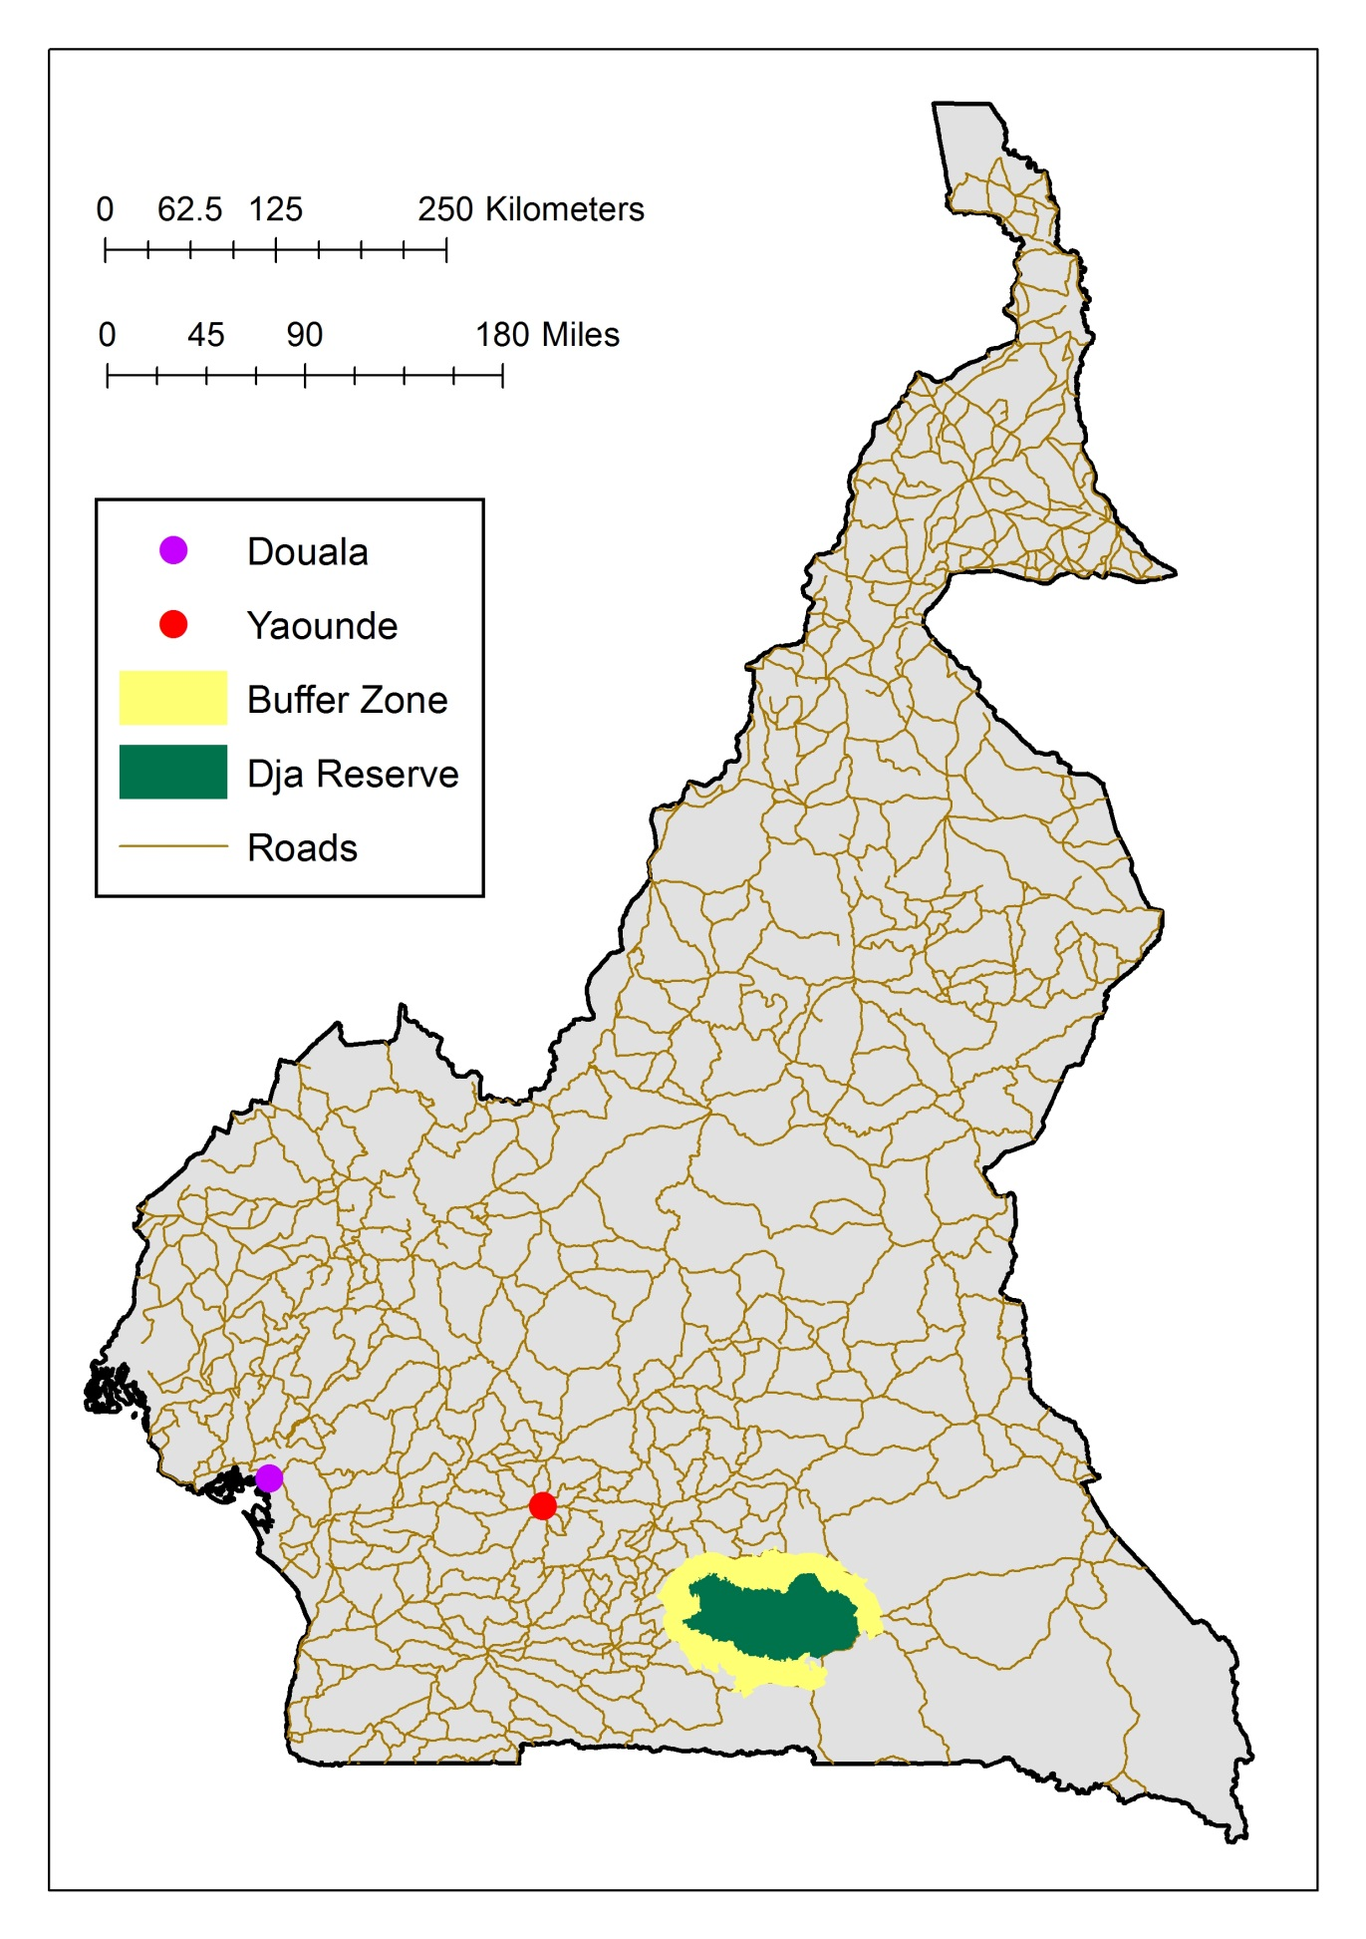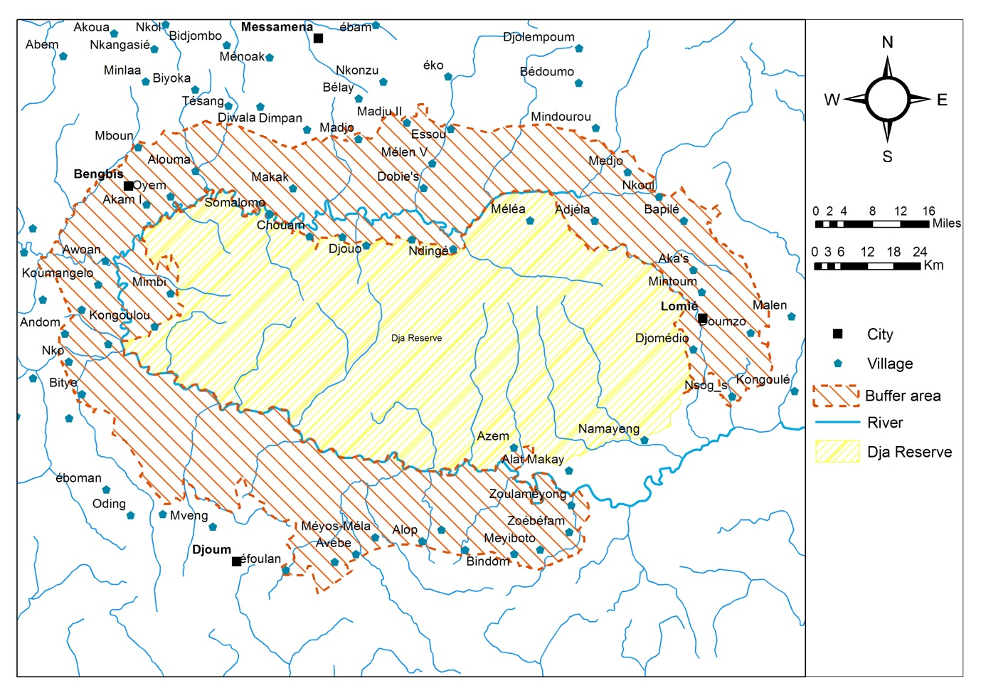

Figure 1. Geographic scope of the Dja Regional REDD+ project.

