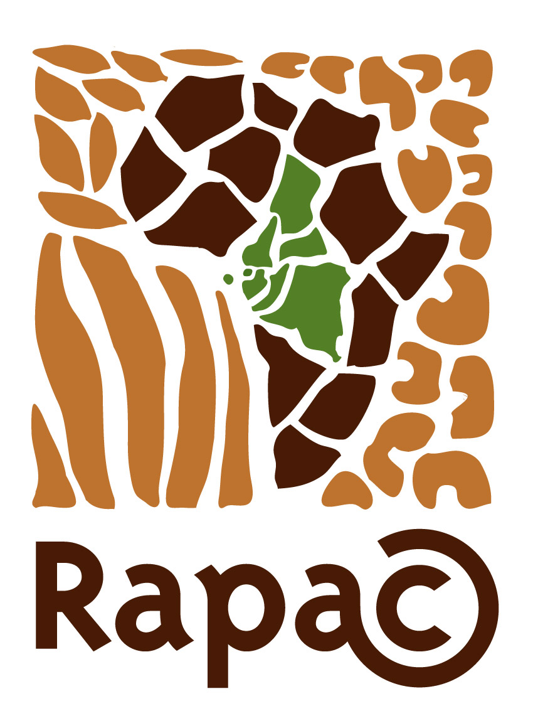
Rede das Áreas Protegidas da África Central
Red de las Areas Protegidas del Africa Central
Central Africa
Protected Areas Network
Réseau des Aires
Protégées
D’Afrique Centrale

Boîte Postale : 14 533 Libreville – Gabon
Tél. (00241) 44 33 22 Fax (00241)73 23 45 secretariat.executif@se-rapac.org
Site web : www.rapac.org N° Statistique: 084 209X

Libreville, 23 June 2016

« Press Release »
For media inquiries contact :
Jean Damascène HAKUZIMANA
Expert En communication au RAPAC
+24104045110 :
communication.rapac@gmail.com

RAPAC - Press Release

The Network of Protected Areas of Central Africa (RAPAC): Regaining Momentum!

Measures to reform RAPAC have started to yield results in repositioning RAPAC as the institution regionally legitimate and credible to support Central Africa’s protected areas. These reforms continue to hit hard after the call of RAPAC’s 17 administrators forming its governing board, who reiterated the reform scenario who met in Malabo/Equatorial Guinea in February 2016.

The same Bureau of Directors of RAPAC agreed to newly brand RAPAC while clarifying its initial mission of serving as a multi-actor sharing and action platform for protected areas, the mission which in 2014 raised concerns and misconception until making RAPAC near a compete dissolution.
The new reforms endorsed by protected areas leaders in Central Africa made RAPAC a sole “regional leader” meant to legitimately support protected areas of Central Africa.

A Unique Board of Directors

The meeting held in Malabo was important because RAPAC’s 17 Board Members underlined the need to complete the implementation of reforms. The Chairman of RAPAC is H.E. Anatolio NDONG MBA, former FAO Representative in various African countries, Minister and Vice-Prime Minister of his country and currently Permanent Representative of Equatorial Guinea to the United Nations.
He was elected for the presidency of RAPAC in 2013 replacing Mr. Samy MANKOTO.
RAPAC’s Chairman presides over the Board of Directors which is a quite unique in the region as each of the eight RAPAC member countries has two representatives (that is 16 Board Members in all): one representative appointed by the State which is the supervisory authority of protected areas, and the other by civil society of each of these eight countries.

Thus, RAPAC is the only regional institution that has an administration with State or non-State representation.

Dr. Cosma WILUNGULA BALONGERWA, the Director General of the Congolese Institute for the Conservation and Nature (ICCN), a RAPAC Board Member representing DRC, feels confident in the structure of RAPAC: “RAPAC is well structured to coordinate sector interventions and its unique status has enhanced its credibility among donors such as the European Union and the International Tropical Timber Organization”.
It is this unique synergy of sector actors that the reform of RAPAC seeks to strengthen and develop by sharing voting rights during its General Meeting equally between two colleges, one for Member States and the other for non-State members. This will enable RAPAC to have as many as non-State members without undermining the sovereignty of Member States.
Omer NTOUGOU NDOUTOUME, the new executive secretary of RAPAC, said that RAPAC’s institutional reforms seeks to effectively open up and widen the involvement of actors involved in the management of protected areas.

The Chairman of RAPAC, H.E. Anatolio NDONG MBA, as the initiator and who still heads this institutional process, expressed his full confidence during the Malabo meeting. “RAPAC is the only sub-regional body that has initiated such far-reaching reforms and which are meant to be evaluated by other international organizations” He Said.

RAPAC’s institutional progress through reforms started attracting attention of actors. The Board of Directors meeting held in Malabo on 9 February 2016 examined Rwanda’s statement to join RAPAC. “Rwanda is bound to join the regional efforts to promote the conservation of the biodiversity of Central Africa’s ecosystems in order to enhance the sustainable development of its population” Explained Télésphore NGOGA, Cross-border Conservation Officer from the Rwanda Development Board -RDB.

A Coherent Strategy Reflected in the Organizational Chart

To strengthen strategic component of this institutional reform, RAPAC has also updated its Action Plan with positive results. According to Jean Pierre AGNANGOYE, RAPAC’s former Executive Secretary and current Technical Adviser to RAPAC. “The ongoing reforms are restoring RAPAC’s technical, legitimate, political, and economic credibility and reputation among the public” Said Jean Pierre who in 2015, proposed to review the institution strategic plan so that it absorbs new expectations of RAPAC’s members and key partners. The same updated plan was validated in Malabo by RAPAC administration council.

The implementation of the “Strategic and Action Plan 2016-2020” consists of three specific objectives and was entrusted to an Executive Secretariat who heads a group of three technical departments headed by experts. According to the new Executive Secretary, Omer NTOUGOU NDOUTOUME, “the role of the three RAPAC experts will be to disseminate and harmonize among field practitioners best practices regarding respectively the management of protected areas by the Technical Credibility Department, the governance and valuation of protected areas by the Socio-economic Legitimacy Department and lastly, the sensitization of various targets by the Public Awareness Department”.

Renewed Partners trust

RAPAC’s reorganization has not only established a link between the strategic and operational aspects, but also restored synergy between RAPAC and its partners. In the words of its Chairman, H.E. Anatoli NDONG MBA: “the reform phase we are implementing has enabled RAPAC to renew the confidence of member countries, technical and financial partners but mainly to stabilize our organization’s structure”.

Partners’ confidence and the institution’s efficiency go hand in hand. The historic partner of RAPAC; the European Union, provided a grant later in 2015 to specifically support the implementation of RAPAC’s reform, including its management. This grant is entitled to equip RAPAC with a standardized and certified financial and administrative department as a key enabler of instutitonnal good management.

The contracting document between RAPAC and the European Union reads that RAPAC faced a 2014 crisis coupled with institutional confusion. The Board of Directors took very bold decisions concerning management and reforms in April 2015 in Libreville. The overall coherence of these measures convinced the European Union to renew its commitment to the institution as said in excerpts of the EU-RAPAC subvention contract. “RAPAC needed radical reforms so that it can continue fulfilling its key and unique role and above all, to contribute to the implementation of the Regional Environmental Programme of the 11th FED”

In recognition of the significant contribution made by some partners, RAPAC’s Board of Directors nominated as Honorary Member, Mr. Enrico PIRONIO of the European Union (DEVCO-C2). This nomination is due to his remarkable efforts to support RAPAC since its inception.
Mr. PIRONIO expressed gratitude for the special honor given to him by RAPAC. “Central Africa, its population and extraordinary and unique natural resources, have had and continue to have a special place in my professional and private life” said PIRONIO.

Visionaries at the Service of Robust Institutions

The decision taken by RAPAC’s Board of Directors to design honorary membership aims at gratifying those who are often hidden behind the institution’s achievements.
They are too many reasons to believe that the RAPAC reforms that were conceived in April, planned in September and financed in November 2015 are already yielding fruits in a timeline of one year. Thanks to the remarkable contribution of the actors of this reform!

While communicating success of RAPAC reform, thanks to people who, at the peak of the 2014 crisis, made commitments to save an emblematic institution that is entrusted with the task of protecting the region’s natural heritage.
It has been a condition that you can’t pretend venturing into protected areas conservation in Central Africa while excluding RAPAC and therefore the need to maintain it and assist it to rise ahead of challenges. The organization’s achievements have been made possible indeed from the dedication of its staff members and technicians.

This is demonstrated by the visionaries who established RAPAC 16 years ago and those supporting it today. The Minister of Agriculture and Forestry of the Republic of Equatorial Guinea meant it while opening officially the February 2016 Malabo meeting: “We should give value to the institutions and organizations that we have set up ourselves such as RAPAC, which supports our countries in managing and developing our protected areas” Said the Minister who reaffirmed his country’s support to RAPAC’s reform efforts and he recalled that RAPAC has supported the development of protected areas in Central Africa and have helped to strengthen Governments’ awareness on the need to protect the biological resources and biodiversity.
He concluded that, “it is therefore an important organization to which we are much attached to and whose work is now recognized worldwide”.
End

www.rapac.org –----communication.rapac@gmail.com

Cameroon, CAR, Congo Brazzaville, DRC, Equatorial Guinea, Sao Tome and Principe, Chad and Gabon where the Headquarters is located.

