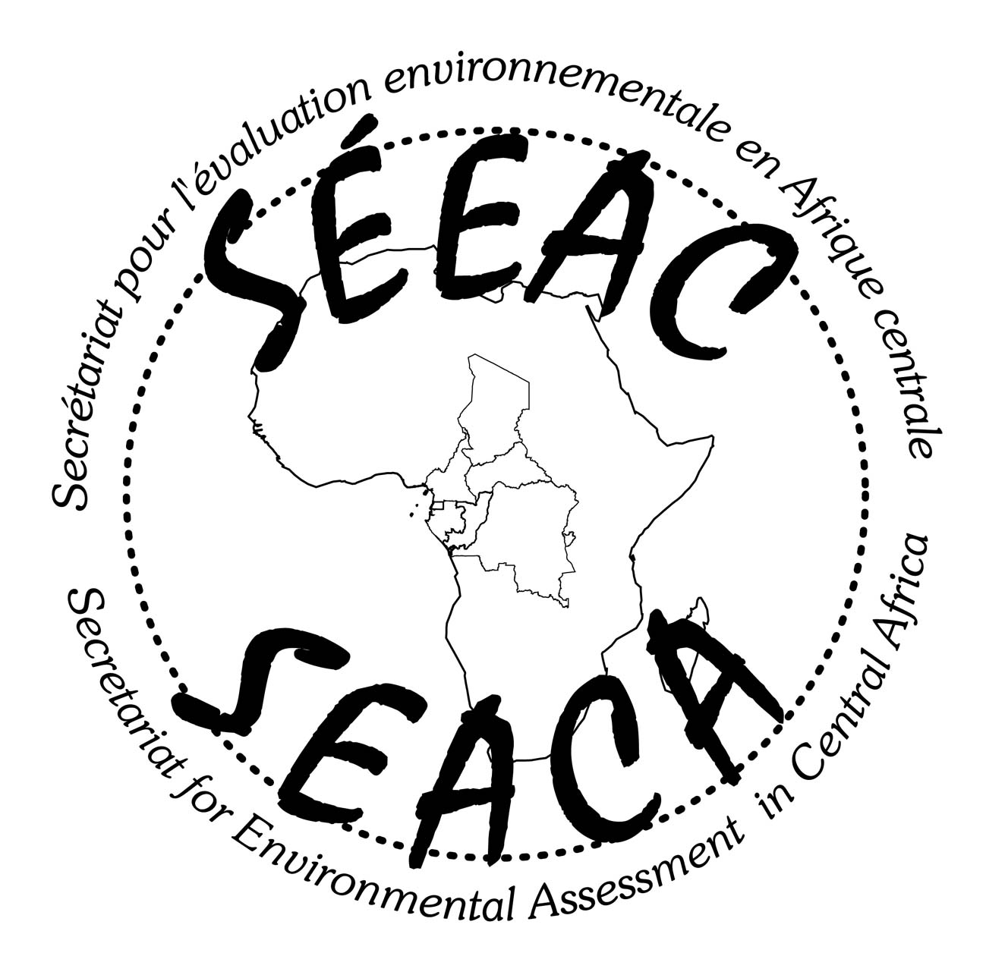
Secretariat of Environmental Assessment in Central Africa
(SEACA)
Association déclaration reciept N°: 001187/RDA/J06/BAPP

Registration Form: 6th International Seminar of SEACA
Mountain Hotel Buea, November 13th - 14^{th,} 2014

Personal data

Gender : Mrs. Mr.
Name : | First name :
Organization or affiliation :
Title or function :
Postal Address:
City : | Phone :
Department | Fax :
Country : | Email 1 :
Post Code : | Email 2 :

……………………………………………………………………………………………………………………………………………………

Payment:

Cheque or western Union – Money Gram mandate (152, 45 €) made in order of the Secretariat for Environmental Assessment in Central Africa

By transfer order to “Secrétariat Exécutif pour l’Evaluation Environnementale en Afrique Centrale » (Bank account n°0231640101582125 NFC BANK CAMEROON.

For any additional information, please send an e-mail to: seeac@seeaconline.org

