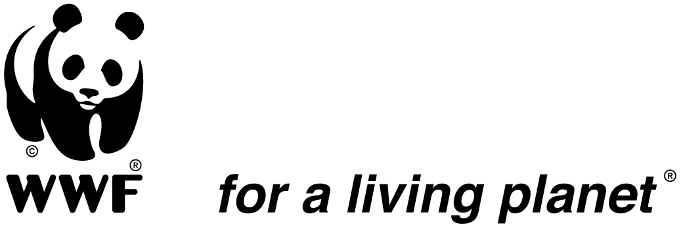

JOB DESCRIPTION

Position title: Salonga Landscape Rural Development Manager
Supervisor: Salonga Park Manager
Supervisees: Technical advisors, consultants and implementing NGOs.
Location: TBD, with frequent trips throughout the Landscape
Duration of Assignment: 2 years contract renewable
Starting Date: August 2016

I. Background

The World Wide Fund for Nature (WWF) has embarked on ambitious, field-based conservation programs across the Congo Basin. In the Democratic Republic of Congo (DRC), WWF is active in several landscape-scale sites, including the over 10 million ha Salonga landscape, which encompasses Salonga National Park (SNP). SNP is the second largest park of humid rainforest in the world. It is also a UNESCO World Heritage site and a critical refuge for bonobos and forest elephants.

WWF’s landscape program works both in the park and in peripheral community and extractive areas. The program takes an integrated conservation approach with a consortium of NGO, government, community, and academic partners. Key conservation strategies include: protected area management; land use planning; law enforcement and species conservation; community-based natural resource management, livelihood improvement; and forest certification.

In 2016, WWF signed a co-management agreement with the national protected area management authority, ICCN (Institut Congolais pour la Conservation de la Nature), to co-manage Salonga National Park. Within this overall context of co-management and landscape-scale conservation, the Salonga Landscape Rural Development Manager will oversee the development and implementation of a rural development strategy in the periphery of SNP. Recognizing that economic development of the rural poor often leads to an increased ability to engage in activities that deplete natural resources, this work will necessitate working closely with the private sector and government departments to provide economic and social facilities that encourage movement away from the park.

II. Main duties:
The Salonga Landscape Rural Development Manager (SLRDM) will have a broad expertise in the planning of large-scale landscapes and rural development, and will be expected to help design and promote a vision for the development of the landscape that has the protection of natural resources at its core. He/she will work closely with the Park Manager and will have primary responsibility for overseeing the coordination of landscape activities outside of Salonga National Park.

He/She shall work with WWF colleagues, including the CAFEC Chief of Party and the WWF Conservation Director, and landscape consortium partners to develop community-based forest management plans and alternative livelihood opportunities, including options linked to the development of palm oil, rubber and cacao using best practices. The position will require establishing strong relationships with provincial governments to develop and implement a shared vision that encourages local employment and includes primary health and educational opportunities for employees recruited from priority areas around the Park.

The position will involve the oversight of administrative, logistical and technical staff within the program, and require the SLRDM to be in regular contact with consortium partners on the ground. The position will also have significant responsibilities as regards coordination and compliance, including work planning and reporting, for key donors supporting the Salonga Landscape.

III. Main tasks and responsibilities:

• Supervision and direction of the development program:
Under the direct supervision of the Park Manager and in close collaboration with the Conservation Director and the CAFEC Chief of Party, strengthen cooperation between all stakeholders and assume overall coordination of the Salonga Landscape Program outside of Salonga National Park. He/she will provide leadership in the strategic design and development of new and innovative livelihood projects according to the agreed strategic development plan. He/she will be responsible for directing the activities in accordance with the project descriptions and provide guidance to the overall program objectives. He/she will take part in national and international discussions to present the progress made and decide the best technical and financial guidelines for conservation focused community and livelihoods activities.

• Technical coordination:
Develop operational plans, budgets and contractual arrangements for activities under WWF direct responsibility and coordinate with partners to ensure the necessary synergies in their implementation. The main areas of technical intervention in Salonga's program are: the management of the periphery of the protected area and consistency with the implementation of its General Management Plan (PGG); the implementation of rural development activities with technical partners; community management of natural resources and integration in REDD+. Additionally, the SLRDM will engage with international and national NGOs and organizations to implement activities on a large scale.

• Management of human and financial resources:
With the direct support of the Human Resources Office and the Finance Department of WWF DRC, the successful candidate will provide technical supervision of the employees of its program and its financial management. He/she will particularly be responsible for ensuring the established procedures for financial partners and WWF, the justification of expenditures, review of financial reporting, budget planning etc., are adhered to. This is to ensure that budgets are approved and expenses justified.

• Strengthening Partnerships:
The candidate will build and maintain a strategic partnership with stakeholders in the landscape in order to develop sustainable community management of natural resources that do not negatively impact on the security of the Park; he/she will also support conflict resolution and cooperation among stakeholders of the landscape through the organization of meetings.

IV. Profile
Required qualifications

- Master's degree in rural development / environment / natural resource management / planning or a relevant field;
- Minimum of 10 years’ experience in rural development with a focus on broad-scale, integrated conservation in and around protected areas;
- Experience in Africa is highly desired;
- Demonstrated experience in multidisciplinary team management.

Required skills and abilities

- Knowledge and understanding of key issues pertaining to biodiversity conservation, including policy issues such as resource rights;
- Knowledge in rural development and markets, including community-based natural resource management;
- Excellent negotiation, consultation and coordination skills;
- Experience in the preparation and implementation of development plans;
- Good administrative, financial, human resource managements and project management skills;
- Excellent oral and written communication abilities in English and French;
- Capacity to work in difficult and complex situations;
- Experience working with international development and donor agencies, particularly USAID, European Union and the German Financial Cooperation;
- Adhere to WWF values: Skills, Optimism, Determination and Commitment.

V. Labour Relations
Internal- close working relationship with the Salonga National Park Manager, USAID-CAFEC Chief of Party, the WWF Director of Conservation, and other program managers such as the Protected Areas Programme, regional and national team to coordinate efforts and mobilize support.

External - working relationship with key partners: the Ministry of Environment and local authorities in the management of protected areas (ICCN). Coordinate interventions in the landscape of CAFEC consortium (CARPE USAID), national and local communities.

WWF has a policy of competitive advantages for its staff. This position is open to candidates with or without family.

Prepared by the supervisor: ________________________ Date: ______________

Reviewed by: __________________________ Date: _______________

Approved by: ________________________ Date: ______________

Accepted by employees: ____________________________ Date: ____________

