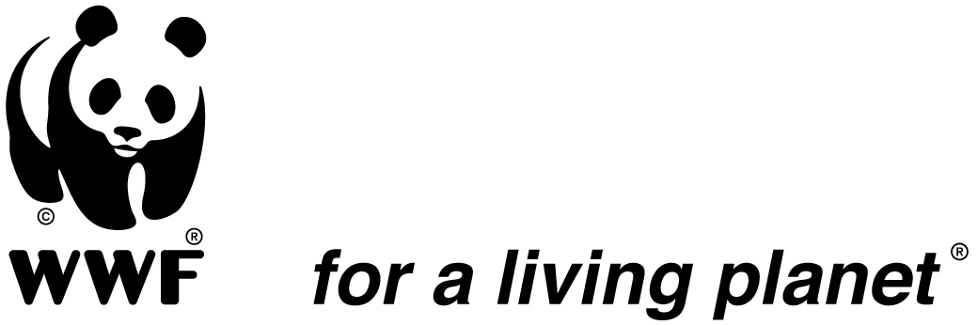

Landscape Rural Development Manager

WWF-DRC is seeking an experienced and qualified Landscape Rural Development Manager who will oversee the development and implementation of a rural development strategy in the periphery of Salonga National Park.
He/she will work closely with the Park Manager in the Salonga National Park.

The position will involve the oversight of administrative, logistical and technical staff within the program, and require the Salonga Landscape Rural Development Manager to be in regular contact with consortium partners on the ground. The position will also have significant responsibilities as regards coordination and compliance, including work planning and reporting, for key donors supporting the Salonga Landscape.

Base location: Monkoto, Democratic Republic of Congo

Required Qualifications, Skills and Competencies:

- Master's degree in rural development / environment / natural resource management / planning or a relevant field;
- Minimum of 10 years’ experience in rural development with a focus on broad-scale, integrated conservation in and around protected areas;
- Experience in Africa is highly desired;
- Demonstrated experience in multidisciplinary team management.
- Knowledge and understanding of key issues pertaining to biodiversity conservation, including policy issues such as resource rights;
- Knowledge in rural development and markets, including community-based natural resource management;
- Excellent negotiation, consultation and coordination skills;
- Experience in the preparation and implementation of development plans;
- Good administrative, financial, human resource managements and project management skills;
- Excellent oral and written communication abilities in English and French;
- Capacity to work in difficult and complex situations;
- Experience working with international development and donor agencies, particularly USAID, European Union and the German Financial Cooperation;
- Adhere to WWF values: Skills, Optimism, Determination and Commitment.

How to apply
Detailed Job Description for this position can be found at WWF’s website www.panda.org under Jobs and as attached. Interested candidates should email a cover letter and curriculum vitae to: recruit-wwfdrc@wwfdrc.org by 30 June 2016.

Only short-listed candidates will be contacted

“WWF is an equal opportunity employer and committed to having a diverse workforce.

