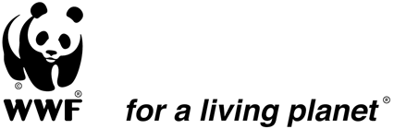

Recruitment of a consultant for the production of a documentary film on the environmental and social impacts of Artisanal and Small Scale Mining (ASM) in Southeastern Cameroon

WWF Cameroon in partnership with the Ministry of Environment, Nature Protection and Sustainable Development
through the Regional Delegation of the East Region is seeking the services of a consultant to produce a documentary film on the environmental and social impacts of artisanal and small scale mining in the TRIDOM and TNS landscapes of Cameroon.

Requirements for Applying:
- The consultant is expected to provide all equipment and personnel required to plan, execute and complete the outputs
- Minimum of five years’ proven work experience in producing high quality, short films/reportage/documentary in Cameroon including writing, producing, directing and editing;
- Ability to represent concepts, qualitative information and key messages using high quality, visually attractive graphics
- Experience in the development, environmental and mining sectors in Cameroon will be an added advantage.
- Ability to operate under strict time limits;
- Ability to effectively apply high production and technical standards for the purpose of maintaining high levels of professionalism;
- Ability to work in the French language;
- Knowledge of the landscape will also be an added advantage for the consultant,
The consultant is expected to provide a technical and financial offer which includes the following;
- Brief information about previous experiences
- Brief bios (CVs) of the key people to be engaged in the production of the documentary;
- A brief synopsis of the documentary including description of work plan and timeframe (methodology)
- A financial offer including all related production costs, per diem and transport

NB: All these elements shall be constituted and sent as a single document in PDF format.
Duration of Assignment: 4 weeks
How to Apply:
Interested applicants shall send their application using the following email address: recruit-cam@wwfcam.org with copy to DHalleson@wwfcam.org and FManga@wwfcam.org on or before the 10th of March 2016

