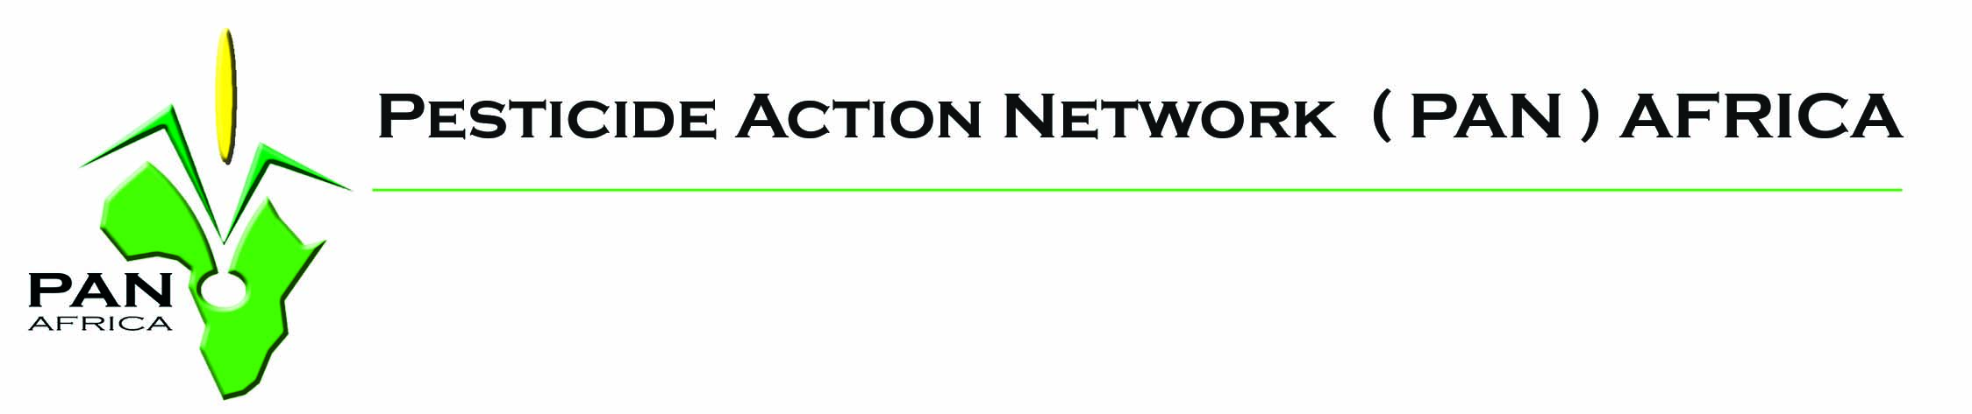

Greengrants Global Fund (GGF): mini grant to small organizations of civil society in Africa
--------------
Greengrants the Global Fund (GGF) is a Foundation based in the United States. It’s provide small grants to small organizations of civil society in the South to carry out activities in the field of Environment and Sustainable Development.

For several years, Pesticide Action Network advises GGF in awarding these grants to organizations in Africa, Latin America, Asia and some East European countries. It is important to note that PAN is only a adviser and does not give grants. This role is exclusively for GGF.

The date for the next cycle for these grants is set early December 2016.

African organizations eligible and wishing to apply, must submit only to PAN Africa a 3-4 page proposal including project objectives, methodology, expected results and activities budget detailed with amounts in U.S. dollars. The requested contribution to GGF should not exceed U.S. $ 3,500.

Proposals must be sent by e-mail no later than November 25, 2016, to panafrica@pan-afrique.org.

Some favorite themes by PAN in recent years are:
- Phase out of Highly Hazardous Pesticides (HHP);
- Fight against the G.M.O;
- Promotion of alternatives to chemical pesticides;
- Community monitoring of the effects of pesticides on health and the environment (Community - Based Monitoring CBM);
- Alternatives to the use of DDT in public health;

A committee will review and select proposals. Priority will be given to organizations that have not yet received this grant. If your proposal is selected you will receive forms that must be returned duly completed and signed before, scanner and send to PAN Africa accompanied by legal official documents of your organization.

Finally, it is asked to provide a report of activities carried out under the project. The report Should be sent to GGF with a copy to PAN Africa no more than 3 months after completion.

For more information on GGF: www.greengrants.org

