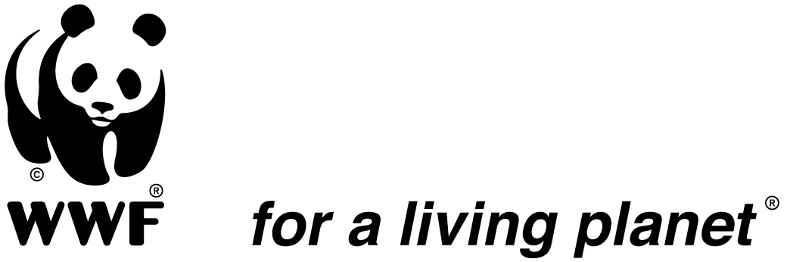

Salonga National Park Manager

WWF-DRC is looking for a Park Manager for the Salonga National Park to help achieve its new ambitious goals and build a future where people live in harmony with nature.

Location:
Monkoto, Democratic of Republic of Congo.

Duration of the assignment: 2 years subject to successful probation renewable subsequently

The Role:
The Park Manager will work closely with partners inside and outside of the park to effect real conservation results. The position supervises WWF and ICCN (Institut Congolais pour la Conservation de la Nature, the Protected Areas Authorities in DRC) staff working in the law enforcement, research, tourism, monitoring, infrastructure, logistics and activities in periphery (community development) and collaborates with partners to advance the park objectives. He will lead the Management Unit of the Park known as UGPNS and will act as a resource person for the Salonga Steering committee.

Main responsibilities:
Provides strategic leadership: To achieve conservation results, including the Park vision; partnership for protected area management (management plan development, implementation, and adaptive management); law enforcement through ICCN rangers, community-based natural resource management; institutional strengthening and training; policies and legislation; regional networking; and project monitoring.

Park oversight and coordination: Plans, directs and oversees park activities in accordance with the annual work plan, budget and contractual agreements. Develops work plans and budgets for approval by WWF and ICCN, partners, the Salonga steering committee, and other participating agencies. Mobilizes and coordinates with government and non-government partners, donors, and other stakeholders in the Park to work towards a common vision on the park while also supporting synergies with the landscape management. Oversees program planning to strengthen progress towards objectives (e.g. strengthen park management, anti-poaching activities). Ensures the organization of regular meetings of the Salonga landscape consortium and concertation committees (CoCoSi).

Park management implementation: Manages the park and its management unit (UGPNS) using a participatory, adaptive management approach. Ensures that management systems are established and oversees the administration of the management plan and related program/projects. Supervises activities. With support from WWF, ensures that project(s) are in compliance with donors’ regulations.

Administration/Financial management: With the direct support of the manager of finance and administration, contribute to the development of project budgets for approval, technical and financial reporting, and monitoring of expenditures against budgets for Park activities.

Required Qualifications, Skills and Competencies
- Advanced university degree in an appropriate field (conservation / environment / natural resource or park management; forest / terrestrial ecology)
- A minimum of 10 years’ experience working in conservation, or development organizations, preferably in a similar biome,
- Project management experience in Africa or elsewhere is strongly desired.
- Strong working knowledge of park management and what it takes to effectively manage a large-scale park. Understanding of forest and wildlife ecology, and natural resource management principles is important.
- Depth and breadth of knowledge of biomonitoring in forested environment and law enforcement procedures;
- Clear understanding of community-based natural resource management and rural livelihood issues.
- Strong administrative and financial management skills and excellent organizational skills.
- Excellent people and project management skills to handle complex, multi-faceted projects, negotiate, and resolve conflicts.
- Excellent oral and written communications skills in French, and a good command of English.
- Experience working with government officials and donors.
- Ability to live and work in remote and difficult conditions.
- Ability to live in multicultural context and acceptance of local values.
- Adherence to WWF’s values, which are: knowledgeable, Optimistic, Determined and Engaging.

For more details, please consult the Job Description attached.

How to apply?
Interested candidates who meet the above requirements are invited to send:
- A cover letter
- A detailed CV with 3 references

All applications should be sent to recruit-wwfdrc@wwfdrc.org. The subject should read SNP-PM
Deadline for applications: 28 February 2017

WWF is an equal opportunity employer and committed to having a diverse workforce.

