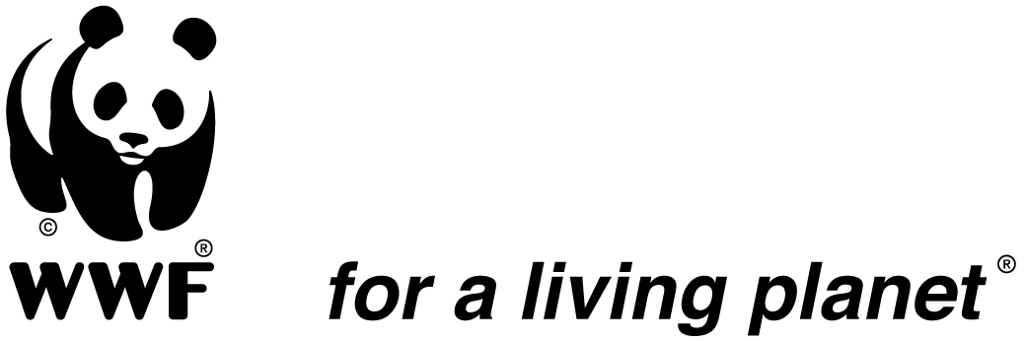
JOB DESCRIPTION

Job Title: Salonga Program Administrator
Supervised by: Program Manager Salonga/Landscape Leader
Supervises: Program Administrative team
Location: Monkoto, DRC
Date: May 2016

Background
The World Wide Fund for Nature (WWF) has launched an ambitious program of conservation in the Congo Basin. In the Democratic Republic of Congo (DRC), WWF is implementing eight action programs including one active since 2005 in the Salonga National Park (PNS) and its landscape. The Salonga National Park, second rainforest protected area of in the world by area, contains a biological diversity of exceptional value. Species, ecosystems, and ecological processes contained in this protected area constitute a heritage of the first order for the Congolese Institute for the Conservation of Nature (ICCN), the DRC, as well as the whole of humanity. However, serious threats weigh on the PNS featuring not only endangering the outstanding universal values of the site but also jeopardizing the initiatives of sustainable management of natural resources in the heart of the Congo Basin.
Under the CAFEC project, funded by USAID, WWF will implement a work program over the next five years primarily oriented towards the protected area and its periphery, the whole forming a priority landscape of the COMIFAC (Central African Forest Commission). This program brings together the ICCN and various conservation NGOs as well as financial partners.
It is also anticipated, with the help of additional funding that WWF will engage, along with ICCN in establishing a co-management procedure involving ICCN to WWF and several other conservation NGOs, supported by funding from several donors including USAID, KfW and the EU, in order to strengthen the management of the PNS.
In this context, the Administrator of the Salonga Program will oversee the implementation of administrative procedures, financial control and human resources of the program based in Monkoto.

- Mission
The Salonga Program Administrator shall be in charge of developing administrative and financial procedures and supervise administrative and logistics staff of the program in collaboration with the local Human Resource Office.

- Major Functions:
- Technical coordination: He/she will assist in the development of operational plans, budgets and contractual arrangements for activities under the direct responsibility of the Salonga Program Manager.
- Human and financial resources management: with the direct support of the Human Resources Office, the Finance Department of WWF DRC and the local Administrative Assistant, the Administrator will provide the technical supervision of program staff as well as its financial management. He/she will be particularly responsible for justification of expenditures, the review of financial reports, budget planning, etc., according to established procedures of financial partners and WWF. He/she will therefore ensure that budgets are approved by the Program Manager and expenditures justified before sending them to the accounting unit. He/she will assist the “Finance, Administration and HR Department” of the PNS so that it can produce, respecting established management procedures, the Park’s annual financial statements (Balance sheet, income statement, detailed explanatory annexes) in a condition to be audited annually by an internationally accredited auditing firm.
- Strengthening partnerships: The Administrator will support the Program Manager in the structuring of a strategic partnership with ICCN and other partners in order to establish a co-management structure leading to a significant improvement in the management of the PNS. This will mainly include: the development of partnership agreements with ICCN and other partners; supporting the development of a Foundation (statutes, structure of entities; establishment of committees etc.); supporting the preparation of descriptions for key positions and capacity-building for the PNS management unit; support the implementation of the operational plan of the PNS; participate in the resolution of conflicts, etc.

- Major duties and responsibilities
- Contribute to the preparation of budgets in accordance with the standards of the WWF and the donor under the supervision of the Program Manager;
- Ensure that adequate finance and administration systems and procedures are operational throughout the WWF sites attached to the program;
- Contribute, in consultation with ICCN’s financial and administrative unit (DAF ICCN) and in close cooperation with partners on the site, in the drafting of the manual of managing budgetary, accounting and financial procedures specific to the PNS, which will be based on the General provisions laid down by the DAF-ICCN;
- Ensure that the “Finance, Administration and HR Department” of the PNS provides rigorous budget and management and rigorous that enables the production, within legal deadlines and according to OHADA standards, of auditable and certifiable annual financial statements;
- Produce and complete on time monthly financial reports, bank reconciliations and financial information requested by the Central office;
- Ensure the development and implementation of financial procedures aligned with the standard of WWF and current Congolese legislation as well as the requirements of donors;
- Prepare requests for funds based on solid expenditure plans consistent with the technical program;
- Ensure a proper posting of expenditures based on authorized budgets as well as proper documentation;
- Prepare and facilitate external and internal financial audits and participate if needed in other monitoring and evaluation processes;
- Prepare contracts and ensure that they are in accordance with current legislation;
- Ensure that the payment of salaries is made in a timely manner;
- Execution of other tasks instructed by the hierarchy for the needs of the service.

- Profile
Required Qualifications
- University degree in economics, business administration or field related to accounting or a degree of equivalent professional training.
- At least 5 years experience in financial and project management in an international or multinational organization would be an advantage.

Required knowledge and Skills
- Capacity of rigorous financial management & accounting with a strong organizational capability;
- A thorough knowledge of, and dexterity with, accounting software;
- Ability to analyze, prioritize and complete tasks with minimal supervision within strict deadlines;
- An understanding of institutions funded by donors, particularly conservation organizations will be a definite advantage.
- This position requires an imaginative (creative) flexible, friendly and cooperative personality;
- Excellent oral and written communication and presentation skills in French and English;
- Good administrative, financial, human resources and project management capabilities.
- Ability to work in difficult, problematic and complex conditions.
- Commitment to the mission of WWF and adherence to WWF’s values which are: Adherence to WWF’s values, which are: Knowledgeable, Optimistic, Determined and Engaging.

- Working Relations
Internal –Close working relations with the Programme Manager, others DRC WWF programme managers such as CAFEC Programme Financial Administrator and the Human Resources Manager in order to coordinate efforts and mobilize support.

External –Working relations with key partners: Ministry of Environment and local authorities in charge of the management of protected areas (ICCN), partner NGOs and local communities.

This job description covers the main tasks and conveys the spirit of the sort of tasks that are anticipated proactively from staff. Other tasks may be assigned as necessary according to organizational needs.

Prepared and supervised by: _________________________________ Date: ____________________

Reviewed by: _____________________________________________ Date: ____________________

Approved by: _____________________________________________ Date: ____________________

Accepted by employee: ______________________________________ Date: ____________________

