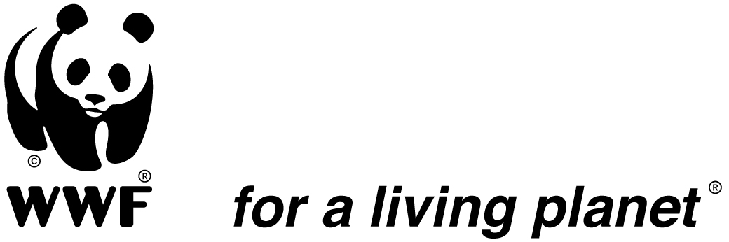

The World Wide Fund for Nature in the DRC seeks a

Program Administrator for the Salonga Program

The World Wide Fund for Nature (WWF) is one of the largest independent conservation organizations in the world. We are an international NGO committed to environmental protection active in almost 100 countries. WWF has been working in the Congo Basin in Central Africa since 1978.
In the Democratic Republic of Congo (DRC), WWF is implementing eight programs including one active since 2005 in the Salonga National Park (PNS) and its landscape. The Salonga National Park, second rainforest protected area of in the world by area, contains a biological diversity of exceptional value. Species, ecosystems, and ecological processes contained in this protected area constitute a heritage of the first order for the Congolese Institute for the Conservation of Nature (ICCN), the DRC, as well as the whole of humanity.
Under the CAFEC project, funded by USAID, WWF will implement a work program over the next five years primarily oriented towards the protected area and its periphery, the whole forming a priority landscape of the COMIFAC (Central African Forest Commission). This program brings together the ICCN and various conservation NGOs as well as financial partners.
It is also anticipated, with the help of additional funding that WWF will engage, along with ICCN in establishing a co-management procedure involving ICCN to WWF and several other conservation NGOs, supported by funding from several donors including USAID, KfW and the EU, in order to strengthen the management of the PNS.
In that context, we are are looking for a dynamic and committed Program Administrator who will oversee the implementation of administrative procedures, financial control and human resources of the Salonga program.

Location: Monkoto, DRC

Duration: 2 years renewable

Main responsibilities:
- Contribute to the preparation of budgets in accordance with the standards of the WWF and the donor under the supervision of the Program Manager;
- Ensure that adequate finance and administration systems and procedures are operational throughout the WWF sites attached to the program;
- Contribute, in consultation with ICCN’s financial and administrative unit (DAF ICCN) and in close cooperation with partners on the site, in the drafting of the manual of managing budgetary, accounting and financial procedures specific to the PNS, which will be based on the General provisions laid down by the DAF-ICCN;
- Ensure that the “Finance, Administration and HR Department” of the PNS provides rigorous budget and management and rigorous that enables the production, within legal deadlines and according to OHADA standards, of auditable and certifiable annual financial statements;
- Produce and complete on time monthly financial reports, bank reconciliations and financial information requested by the central office.

What you need:
Required Qualifications
- University degree in economics, business administration or field related to accounting or a degree of equivalent professional training;
- At least 5 year-experience in financial and project management in an international or multinational organization would be an advantage.

Required skills and competencies
- Capacity of rigorous financial management & accounting with a strong organizational capability;
- A thorough knowledge of, and dexterity with, accounting software;
- Ability to analyze, prioritize and complete tasks with minimal supervision within strict deadlines;
- An understanding of institutions funded by donors, particularly conservation organizations will be an advantage;
- This position requires an imaginative (creative) flexible, friendly and cooperative personality;
- Excellent oral and written communication and presentation skills in French and English;
- Good administrative, financial, human resources and project management capabilities;
- Ability to work in difficult, problematic and complex conditions;
- Commitment to the mission of WWF and adherence to WWF’s values which are: Knowledgeable, Optimistic, Determined and Engaging.

This position is opened to candidates with or without a family.

Please consult the attached job description for more information on the position.

How to apply?
Email a cover letter and CV to recruit-wwfdrc@wwfdrc.org
The subject should read RDC-SPA. Deadline for applications: 29 March, 2016. Thank you in advance for your interest in this position. Please note that only candidates under serious consideration will be contacted for follow up. If you have not been contacted six (6) weeks after closing, consider your application unsuccessful.

Female applicants are encouraged.

WWF is an equal opportunity employer and committed to having a diverse workforce

